**CREATE CHECKBOX USING C++ BUILDER**

**Source Code**

//---------------------------------------------------------------------------

#include <vcl\vcl.h>

#pragma hdrstop

#include "CheckBox.h"

//---------------------------------------------------------------------------

#pragma resource "*.dfm"

TForm1 *Form1;

//---------------------------------------------------------------------------

__fastcall TForm1::TForm1(TComponent* Owner)

: TForm(Owner)

{

}

//---------------------------------------------------------------------------

void __fastcall TForm1::Button1Click(TObject *Sender)

{

//Boundary Lines

//From point (10,10)

Form1->Canvas->Pen->Width=2;

Form1->Canvas->MoveTo(10,10);

Form1->Canvas->LineTo(10,50);

Form1->Canvas->MoveTo(10,10);

Form1->Canvas->LineTo(50,10);

//From Point (50,50)

Form1->Canvas->MoveTo(50,10);

Form1->Canvas->LineTo(50,50);

Form1->Canvas->MoveTo(10,50);

Form1->Canvas->LineTo(50,50);

//Diagonal

Form1->Canvas->MoveTo(10,10);

Form1->Canvas->LineTo(50,50);

Form1->Canvas->MoveTo(50,10);

Form1->Canvas->LineTo(10,50);

//Vertical lines

Form1->Canvas->MoveTo(20,10);

Form1->Canvas->LineTo(20,50);

Form1->Canvas->MoveTo(30,10);

Form1->Canvas->LineTo(30,50);

Form1->Canvas->MoveTo(40,10);

Form1->Canvas->LineTo(40,50);

//Horizontal Lines

Form1->Canvas->MoveTo(10,20);

Form1->Canvas->LineTo(50,20);

Form1->Canvas->MoveTo(10,30);

Form1->Canvas->LineTo(50,30);

Form1->Canvas->MoveTo(10,40);

Form1->Canvas->LineTo(50,40);

}

//---------------------------------------------------------------------------

**Output**

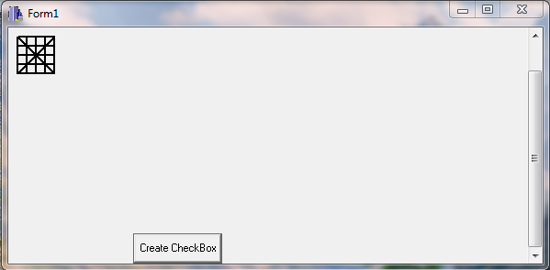

**CREATE A CALCULATOR USING C++ BUILDER**

**Source Code**

//---------------------------------------------------------------------------

#include <vcl\vcl.h>

#pragma hdrstop

#include "Unit1.h"

//---------------------------------------------------------------------------

#pragma package (smart, init)

#pragma resource "*.dfm"

TForm1 *Form1;

int x,y,z;

int flag=0,oper;

//---------------------------------------------------------------------------

__fastcall TForm1::TForm1(TComponent* Owner)

: TForm(Owner)

{

}

int setvalue(int a)

{

if(flag==0)

{

x=a;

flag=1;

return x;

}

else

{

y=a;

flag==0;

return y;

}

}

//---------------------------------------------------------------------------

void __fastcall TForm1::Button7Click(TObject *Sender)

{

Edit1->Text=setvalue(1);

}

//---------------------------------------------------------------------------

void __fastcall TForm1::Button8Click(TObject *Sender)

{

Edit1->Text=setvalue(2);

}

//---------------------------------------------------------------------------

void __fastcall TForm1::Button9Click(TObject *Sender)

{

Edit1->Text=setvalue(3);

}

//---------------------------------------------------------------------------

void __fastcall TForm1::Button4Click(TObject *Sender)

{

Edit1->Text=setvalue(4);

}

//---------------------------------------------------------------------------

void __fastcall TForm1::Button5Click(TObject *Sender)

{

Edit1->Text=setvalue(5);

}

//---------------------------------------------------------------------------

void __fastcall TForm1::Button6Click(TObject *Sender)

{

Edit1->Text=setvalue(6);

}

//---------------------------------------------------------------------------

void __fastcall TForm1::Button1Click(TObject *Sender)

{

Edit1->Text=setvalue(7);

}

//---------------------------------------------------------------------------

void __fastcall TForm1::Button2Click(TObject *Sender)

{

Edit1->Text=setvalue(8);

}

//---------------------------------------------------------------------------

void __fastcall TForm1::Button3Click(TObject *Sender)

{

Edit1->Text=setvalue(9);

}

//---------------------------------------------------------------------------

void __fastcall TForm1::Button11Click(TObject *Sender)

{

Edit1->Text=setvalue(0);

}

//---------------------------------------------------------------------------

void __fastcall TForm1::Button12Click(TObject *Sender)

{

switch(oper)

{

case 1:

z=x+y;

break;

case 2:

z=x-y;

break;

case 3:

z=x*y;

break;

case 4:

z=x/y;

break;

}

Edit1->Text=z;

}

//---------------------------------------------------------------------------

void __fastcall TForm1::Button13Click(TObject *Sender)

{

oper=1;

}

//---------------------------------------------------------------------------

void __fastcall TForm1::Button14Click(TObject *Sender)

{

oper=2;

}

//---------------------------------------------------------------------------

void __fastcall TForm1::Button15Click(TObject *Sender)

{

oper=3;

}

//---------------------------------------------------------------------------

void __fastcall TForm1::Button16Click(TObject *Sender)

{

oper=4;

}

//----------

**Output**

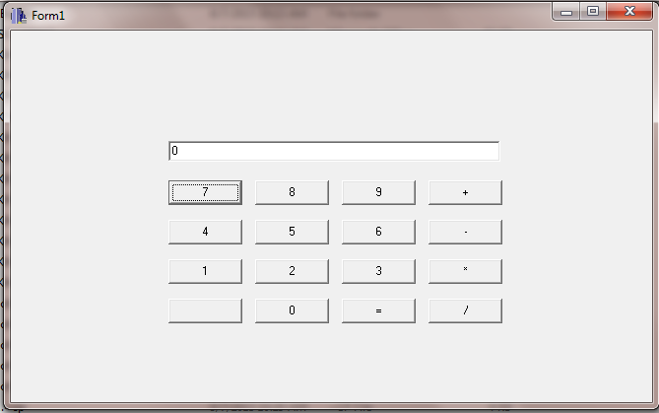

1. **Addition of 5 and 6**

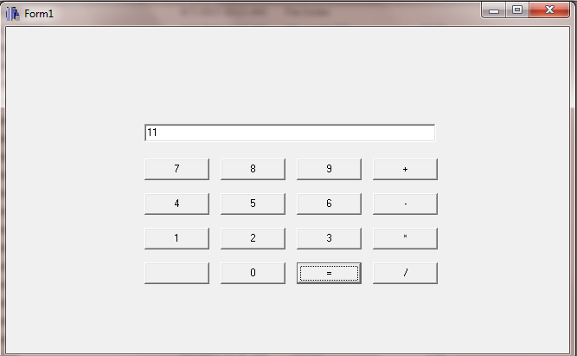

1. **Subtraction of 6 from 5**

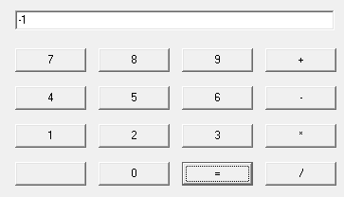

1. **Multiplication of 5 and 6**

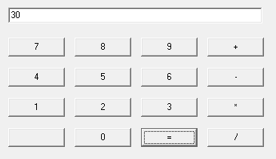

1. **Division of 6 by 5**

